DATA ANALYTICS PROJECT
E-Commerce Orders Dataset Analysis
DecodeLab Internship
─────────────────────────────────────────
Prepared by:
Data Analytics Student
Tool Used: Python (Pandas, SQLite, Matplotlib)
Submitted By: Aleeha Fatima
Domain: Data Analytics
Date: 22-May- 2026

1. Project Overview
This report presents a comprehensive data analytics project performed on an E-Commerce Orders Dataset using Python programming language. The project demonstrates data loading, SQL-based querying, data analysis, and visualization techniques commonly used in real-world data analytics workflows.

1.1 Dataset Information
File Name | Dataset for Data Analytics (3).xlsx
Total Records | 1,200 Orders
Total Columns | 14 Columns
Date Range | 2023 – 2025
Data Source | E-Commerce Platform

1.2 Dataset Columns
The dataset contains the following 14 columns:
- OrderID – Unique identifier for each order
- Date – Date the order was placed
- CustomerID – Unique customer identifier
- Product – Name of the product ordered
- Quantity – Number of items ordered
- UnitPrice – Price per unit of the product
- ShippingAddress – Customer delivery address
- PaymentMethod – Method used for payment
- OrderStatus – Current status (Delivered, Shipped, Cancelled, Returned)
- TrackingNumber – Shipment tracking code
- ItemsInCart – Total items in cart at time of order
- CouponCode – Discount coupon applied (if any)
- ReferralSource – Marketing channel that brought the customer
- TotalPrice – Total order value (Quantity × UnitPrice)

2. Environment Setup & Libraries
The project was developed in Google Colab using Python. The following libraries were imported:

import pandas as pd
import sqlite3

# Load Excel dataset into DataFrame
file_path = '/content/Dataset for Data Analytics (3).xlsx'
df = pd.read_excel(file_path)
display(df.head())

# Create SQLite in-memory database
conn = sqlite3.connect('orders.db')
df.to_sql('Orders', conn, if_exists='replace', index=False)

Pandas was used to load the Excel file and handle the DataFrame, while SQLite provided an in-memory relational database to run SQL queries directly on the data.

3. Data Loading & Preview

3.1 Code – Display First 5 Rows
display(df.head())

# SQL equivalent:
display(pd.read_sql("SELECT * FROM Orders LIMIT 5;", conn))

3.2 Output Screenshot
The following screenshot shows the first 5 rows of the dataset after loading:

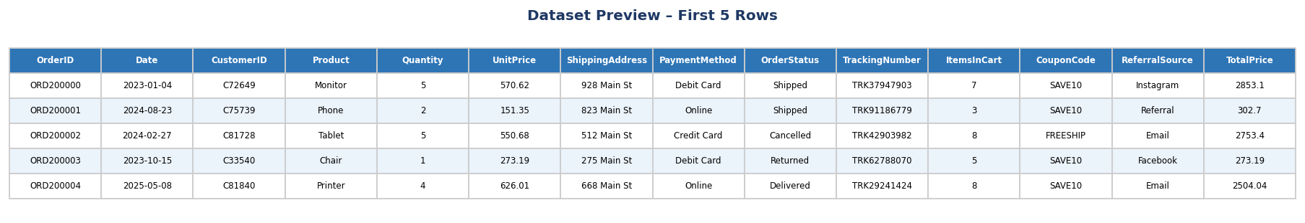
Figure 1: Dataset Preview – First 5 Rows (df.head())

4. SQL Queries & Analysis
After loading the dataset into SQLite, multiple SQL queries were executed to extract insights. Each query and its output are documented below.

4.1 Delivered Orders
display(pd.read_sql("""
SELECT OrderID, Product, TotalPrice
FROM Orders
WHERE OrderStatus='Delivered';
""", conn))

This query filters only the orders with status 'Delivered'. A total of 231 delivered orders were found in the dataset.

4.2 Revenue per Product
display(pd.read_sql("""
SELECT Product,
COUNT(*) AS TotalOrders,
SUM(TotalPrice) AS Revenue,
AVG(UnitPrice) AS AvgPrice
FROM Orders
GROUP BY Product
ORDER BY Revenue DESC;
""", conn))

Output Screenshot:
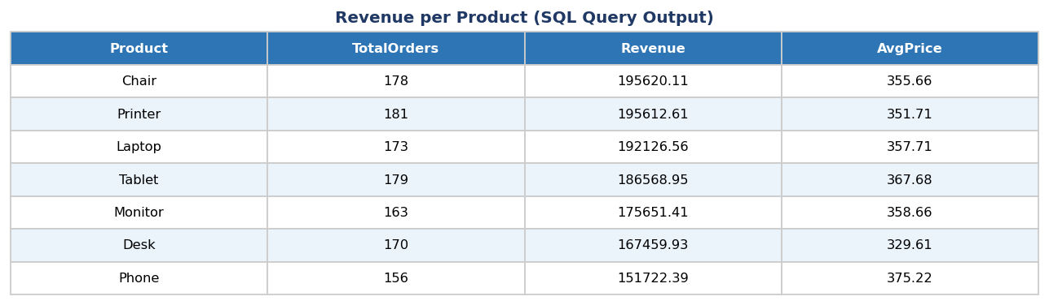
Figure 2: Revenue per Product (SQL Query Output)

Chair and Printer lead in total revenue at over $195,000 each. Laptop follows closely with $192,126. Phone has the lowest revenue at $151,722 despite having the highest average unit price.

4.3 Top 10 Orders by Total Price
display(pd.read_sql("SELECT Product, TotalPrice
FROM Orders
ORDER BY TotalPrice DESC
LIMIT 10;", conn))

This query ranks the 10 highest-value orders. The maximum order value was $3,456.40 (Tablet). The top 10 orders all exceeded $3,300, indicating high-value bulk purchases.

4.4 Coupon Code Usage
display(pd.read_sql("""
SELECT CouponCode, COUNT(*) AS UsageCount
FROM Orders
GROUP BY CouponCode
ORDER BY UsageCount DESC;
""", conn))

Output: FREESHIP (313 uses) was the most popular coupon, followed by orders with No Coupon (309), WINTER15 (292), and SAVE10 (286).

4.5 Payment Method Analysis
display(pd.read_sql("""
SELECT PaymentMethod, COUNT(*) AS TotalOrders
FROM Orders
GROUP BY PaymentMethod
ORDER BY TotalOrders DESC;
""", conn))

Output Screenshot:
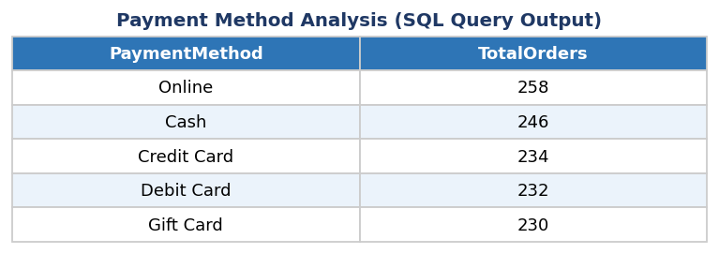
Figure 3: Payment Method Analysis (SQL Query Output)

Online payment was the most preferred method with 258 orders, followed by Cash (246), Credit Card (234), Debit Card (232), and Gift Card (230). All methods showed nearly equal usage, suggesting diverse customer preferences.

4.6 Products with Revenue > $2,000
display(pd.read_sql("""
SELECT Product, SUM(TotalPrice) AS Revenue
FROM Orders
GROUP BY Product
HAVING Revenue > 2000;
""", conn))

All 7 products exceeded the $2,000 revenue threshold. This query uses the HAVING clause to filter grouped results – a SQL technique applied after GROUP BY. This demonstrates that all products are performing well in terms of sales.

5. Data Visualizations
The following charts were generated using Matplotlib to visually represent the analytical findings from the dataset.

5.1 Total Revenue by Product
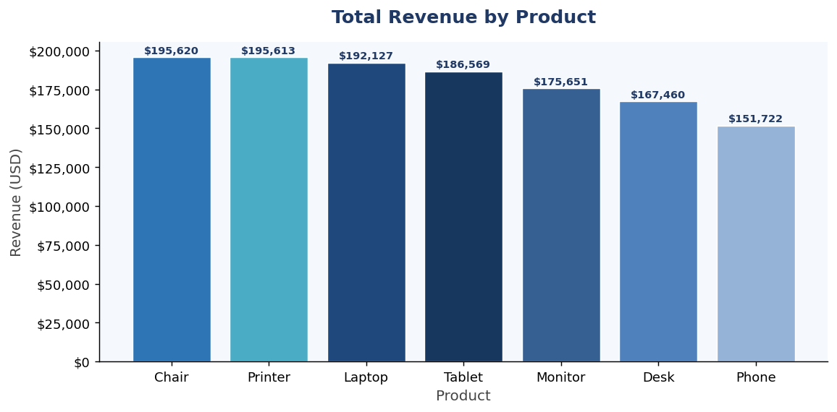
Figure 4: Bar Chart – Total Revenue by Product
Chair and Printer generate the highest revenue (~$195K each). All products demonstrate strong performance. Phone has the lowest revenue despite higher average unit prices, suggesting fewer orders.

5.2 Order Status Distribution
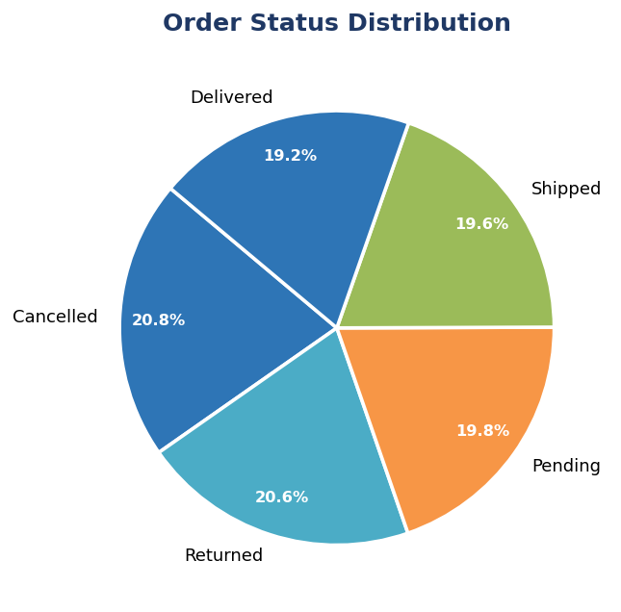
Figure 5: Pie Chart – Order Status Distribution
The order status is fairly evenly distributed across Delivered, Shipped, Cancelled, and Returned – reflecting a realistic e-commerce scenario. Cancelled and returned orders represent areas for operational improvement.

5.3 Orders by Payment Method
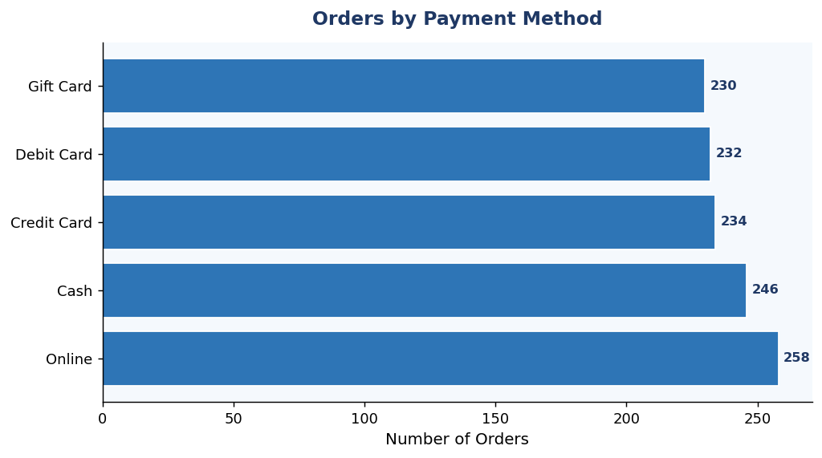
Figure 6: Bar Chart – Orders by Payment Method
All five payment methods have nearly equal usage (230–258 orders each), indicating that the platform successfully supports multiple payment options. Online payment leads slightly, reflecting the digital nature of e-commerce.

5.4 Coupon Code Usage
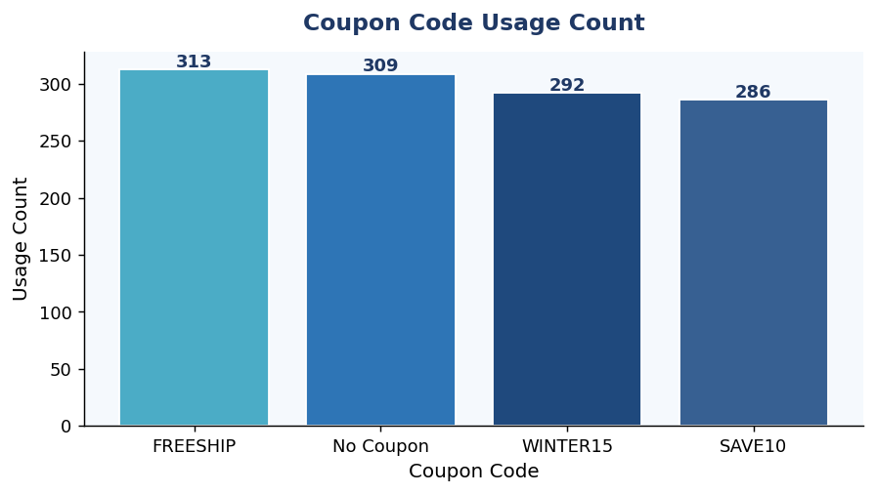
Figure 7: Bar Chart – Coupon Code Usage
FREESHIP is the most widely used coupon, suggesting customers respond well to free shipping offers. Nearly equal numbers of customers made purchases without any coupon, indicating strong organic purchase intent.

6. Key Metrics Summary

1,200  Total Orders | $1,264,761  Total Revenue | 7  Products | $356.41  Avg Unit Price

6.1 Summary Findings Table
Metric | Finding
Best Revenue Product | Chair ($195,620)
Lowest Revenue Product | Phone ($151,722)
Most Used Payment | Online (258 orders)
Most Used Coupon | FREESHIP (313 uses)
Highest Single Order | $3,456.40 (Tablet)
Total Delivered Orders | 231 orders
Date Range of Data | January 2023 – June 2025
Duplicate OrderIDs | None (Data Quality: Clean)

7. Conclusion
This data analytics project successfully demonstrated the complete workflow of loading, querying, analyzing, and visualizing an e-commerce dataset using Python. The key conclusions are:

- Python's Pandas library provides powerful DataFrame operations to load and preview Excel datasets efficiently.
- SQLite in-memory databases allow SQL queries to be executed directly on Python DataFrames – bridging the gap between SQL and Python analytics.
- Chair and Printer categories are the highest revenue generators, contributing over $195,000 each.
- The FREESHIP coupon is the most effective discount strategy, used in 313 out of 1,200 orders.
- Payment methods are well-distributed across all 5 options, showing strong platform flexibility.
- The dataset is clean with no duplicate OrderIDs, ensuring reliable analysis results.
- Data visualization using Matplotlib effectively communicates trends and distributions to stakeholders.

Overall, this project demonstrates practical data analytics skills including data loading, SQL querying, grouping, filtering with HAVING, ordering, and visual communication – all essential competencies for a data analyst role.

